Balachandran, Ryan 3/31/2022
Course Number: PHYS.1410L
Section Number: 804
Instructor: Dr. Mittler
Partners(s): Anthony, Brian, Ryan, Alyssa, Sophia, Justin

Uniform Circular Motion
Introduction
In this experiment, we studied Uniform Circular Motion (UCM). UCM is where an object moves in a circular path with constant speed. Maintaining this motion requires a force that continually acts on the object, pulling it towards the center of the circular path to prevent it from escaping its path. This force is known as centripetal force. In our experiment, we will study how varying the different parameters involved in uniform circular motion are related to each other.

Theory
When studying uniform circular motion, it is helpful to distinguish a coordinate system, such as r, t, z.
r: is the radius from the center to the object being moved in a circular motion. It is the acceleration component of the object which only has a radial component (Horizontal axis).
t: is the velocity which only has a tangential component relative to the circular motion (Horizontal axis).
z: is the axis going up and down when conducting the experiment
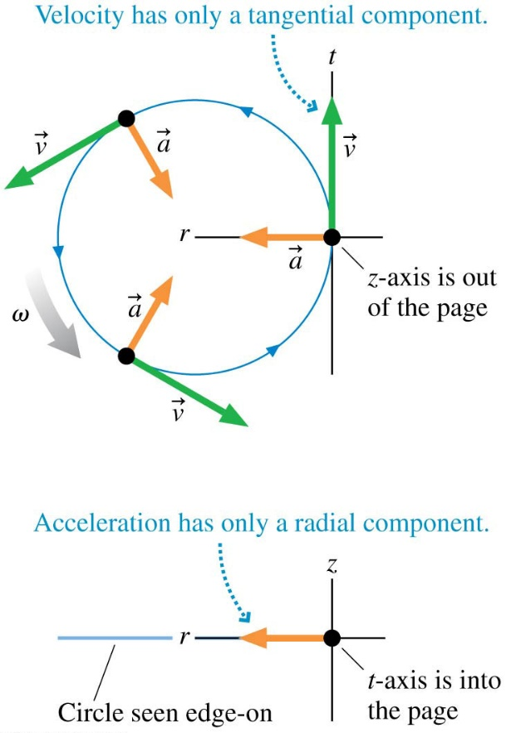
The motion of the object can be described by the following relationships:
$v_{r}=0$ : This is the angular velocity which is zero. When setting the parameters of the experiment, the knurled rod is moved at a constant rate until the orange indicator disk stays aligned with the position indicator bracket, making the angular velocity constant.
$a_{r}=\frac{v^{2}}{r}=ω^{2}r$ : This is the angular acceleration, which is angular velocity $ω$ squared times the radius, where angular velocity is $\frac{2π}{T}$, with T being the period, the time it takes an object to make 1 full rotation.
Angular acceleration from rotation can be derived from Linear velocity. a is acceleration in linear motion, with $α$ being angular acceleration for rotation. $a_{r}=\frac{v^{r}}{r}=\frac{{(rω)}^{2}}{r}=\frac{r^{2}ω^{2}}{r}=ω^{2}r$
$F_{r}=ma_{r}=mω^{2}r$ : This is the angular force ($mass*velocity squared*radius$)
$v_{t}=ωr$ : This is the tangential velocity which is constant for an object in uniform circular motion, therefore, angular velocity must also be constant for this experiment.
The rest of the relationships: tangential acceleration, tangential force, velocity, acceleration and force in the z direction are all zero.

Apparatus and Procedure
Materials:
- Rotating Mass (m)
- Calibrating Mass (M)
- Photogate
- Side Post
- Spring
- Center Post
- Orange Indicator Disk
- Position Indicator Bracket
- Knurled Rod

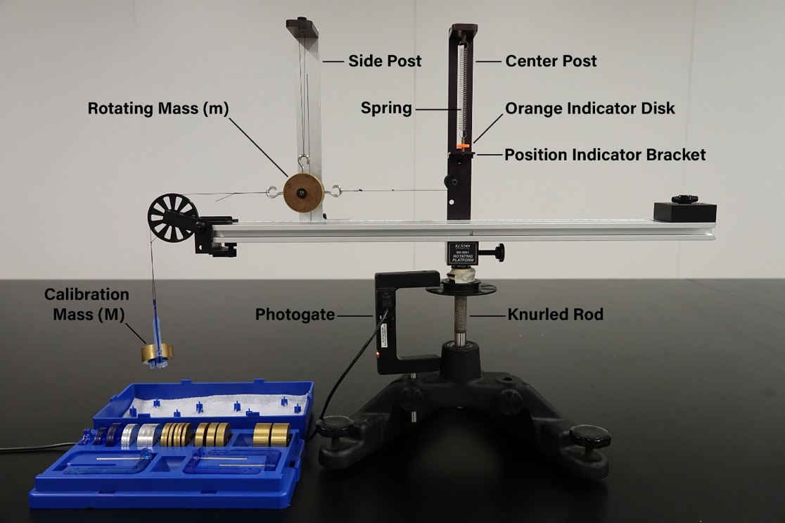
Procedure

For the experiment, there were 3 different parts where we split up into 3 teams of 4-5, so each group had varying data for each of the constants besides radius. For each of the data sets, two parameters will be held constant while a third is varied. The parameters include radius (r), rotating mass (m), and centripetal force ($F_{r}$). For each of the measurements, we set the radius (r), rotating mass (m) and the calibrating mass (M) in the application before beginning the experiment.

Part A:
The mass of the rotating bob and radius were constant at 0.2094kg and 0.15m respectively. The centripetal force was measured using 6 different values for the calibration mass, beginning with 0.065kg and reducing it by 0.010kg until we reached 0.015kg.

Part B:
The mass of the calibration mass and the radius were constant at 0.055kg and 0.15m respectively. The mass of the bob was measured with 5 different masses from 0 to 4 additional masses on the rotating mass.

Part C:
The calibration mass and rotating mass were constant at 0.055kg and 0.208kg respectively. The radius was measured with 4 different values ranging from 0.13 to 0.17m.

Once the appropriate parameters are set, we turned the knurled rod until the orange indicator disk was level with the position indicator bracket, making the angular velocity constant.

Results and Data

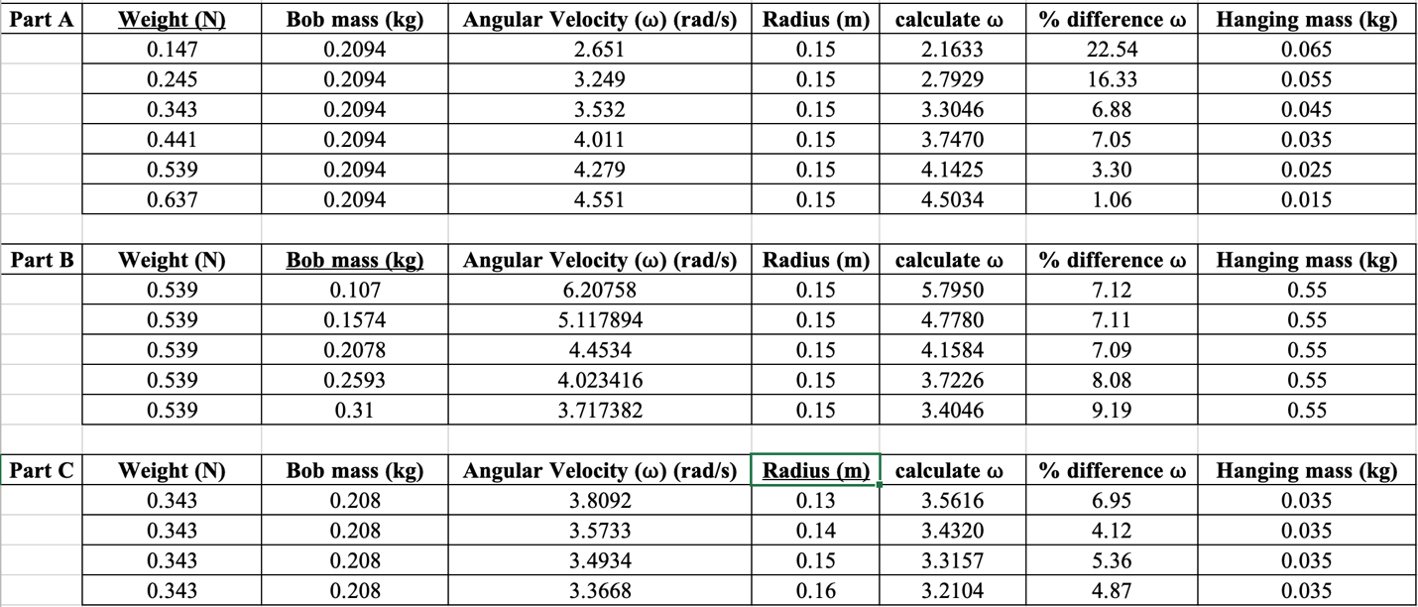
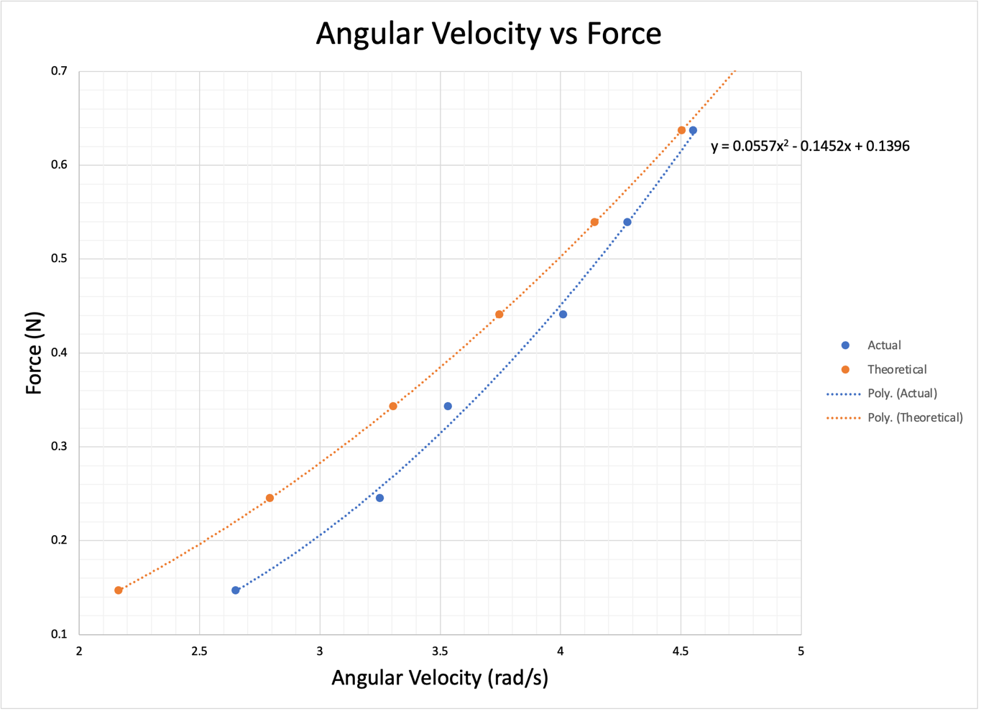
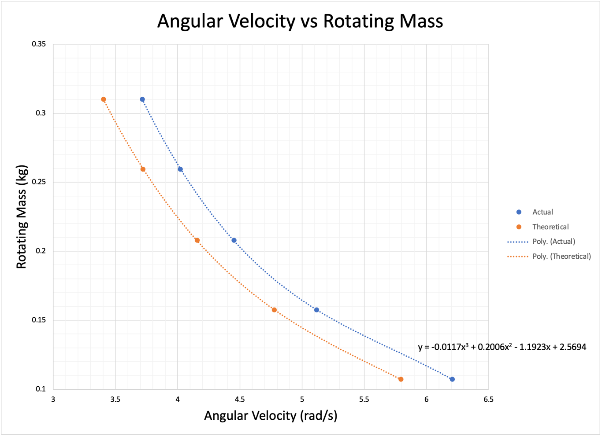
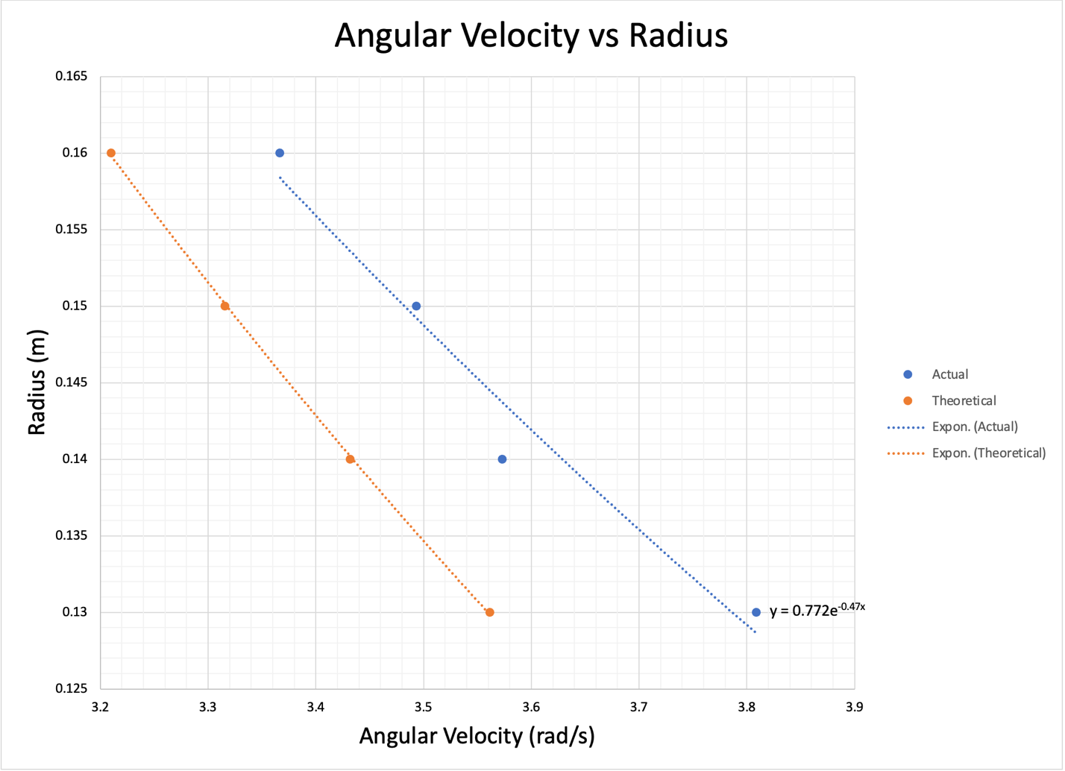

Analysis

Part A: Both slopes for the Actual and Theoretical data are relatively the same even though the percent difference is 22% for the first data point compared to the 1% for the last data point. The percent difference could be attributed to the gradual better understanding of how to change the weight of the calibration mass and having to readjust the position indicator bracket with the orange indicator disk.

The data points are overall consistent with the theory of force increasing as angular velocity increases.

Part B: Both slopes look nearly identical, with the actual data points translated over a little. The percent difference stayed between 7 and 9% and the data points are consistent with the theory that the angular velocity increases as the mass of the rotating object decreases.

Part C: Both slopes are difficult to compare except for the small percent difference of 4 to 6%. This could be contributed to a variety of errors or difficulty understanding the procedures and how to set the radius for each of the four runs. Another factor could be there were only 4 different radius values tested compared to the 5 for part b and 6 for part c. The data points are consistent with the theory that angular velocity increases as radius decreases.
Discussion

The percent difference between the actual and theoretical values for the three graphs of angular velocity vs radius/rotating mass/force are between 4% and 22%.

Part A had the largest variation between the actual and theoretical values of 22% for the first data point, but that quickly decreased to 1% for the final data point. This could be due to the difficulty in understanding the procedures and the gradual understanding of how to change the weight of the calibration mass and having to readjust the position indicator with the orange indicator disk. The experiment for part a confirmed that the change in force increased the angular velocity.

For part B, I believe we did a pretty good job with measuring the effects of the changing values of the Bob mass with angular velocity. Our experiment confirmed the theory that the angular velocity increases as the weight of the object decreases. Our percent difference between the actual and theoretical values were relatively small, between 7 and 9%.

For part C, I believe was the most difficult to accurately gather data on despite the percent difference being smaller than part B. This experiment confirms that the smaller the radius, the higher the angular velocity. The relation of the radius is inverse to angular velocity.

Conclusion

The overall goal of the experiment was to study the effects of how varying the parameters of radius, rotating mass and angular force in uniform circular motion are related to each other. In part A, we can see that angular force is directly proportionate to angular velocity. As force increase, so too does angular velocity. In part B, we see that angular velocity is inversely proportional to the weight of the rotating mass. As the weight of the rotating mass decreases, the angular velocity increases. In part C, we see that angular velocity and radius is also inversely proportional. As the radius of the circle decreases, the angular velocity increases.

Questions
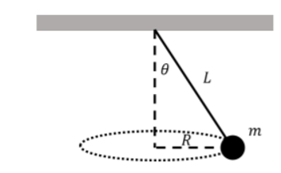

a)
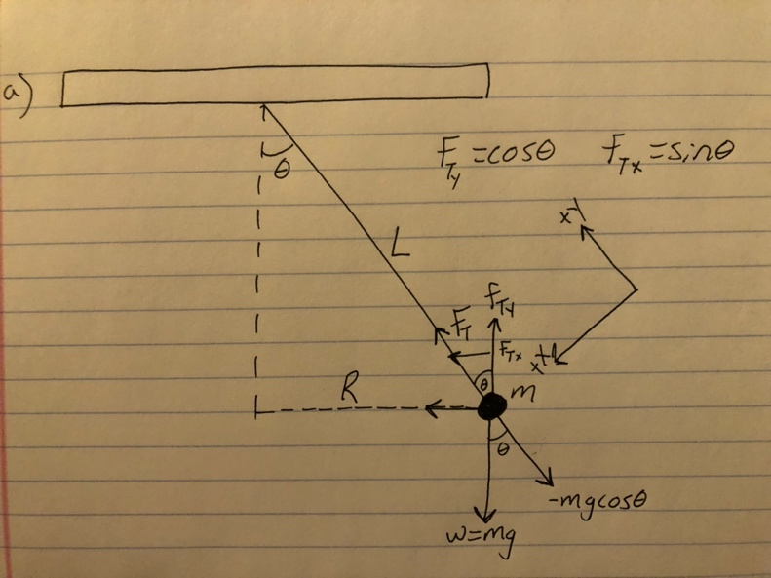
b) $T=\frac{mg}{cosθ}$

c) $v= \sqrt{rgtanθ}$

d) $T=2π\sqrt{\frac{L*cosθ}{g}}$

e) A simple pendulum swings in 2 dimensions and maps out a sector of a circle while a conical pendulum swings in 3 dimensions and maps out the curved surface of a cone.

The period of a simple pendulum depends on the square root of length of the string and the acceleration due to gravity. The period of a conical pendulum depends on the square root of the length of the string, the acceleration due to gravity and the cosine of the semi vertical angle.

For the conical pendulum $θ<10$, the time period obtained is almost the same as the time period for a simple pendulum having the same length as that of a conical pendulum. The only thig that affects the period is the length of the string for both a simple and conical pendulum.

I believe the period is longer for the simple pendulum because it does not have uniform circular motion while the conical pendulum has uniform circular motion.

